Neuromancers Project Proposal

[Link to Preprocessing Document](https://docs.google.com/document/d/1eUD4gq-OfLsOQ-UbfLerD68NmfwXnJ5ygNSPJ3VC77Y/edit?usp=sharing)

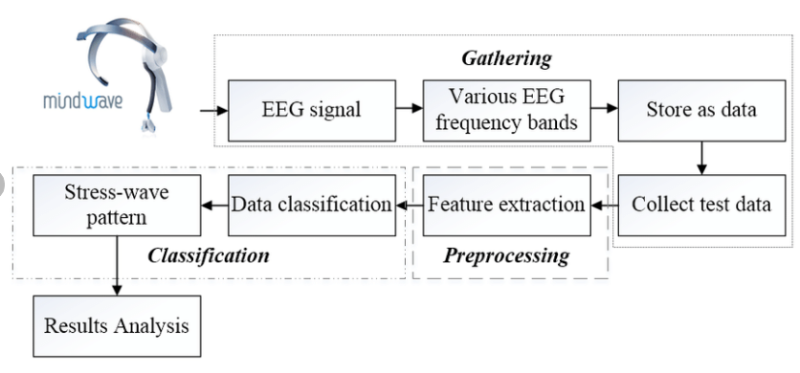

1. Topic
   1. Stress detector and appropriate response (calming music etc.)
   2. Head EEG required
2. Literature Review
   1. <https://www.tandfonline.com/doi/abs/10.1080/02522667.2020.1714187>
      1. Methodology for detecting stress thru EEG signal analysis and classification techniques
      2. Steps:
         1. Preprocessing:
            1. remove power line and ocular noise
            2. Bi-orthogonal Wavelet Decomposition
            3. FIR filter + IIR filter w/ zero phase + butterworth filter + high/low pass
         2. Feature extraction: Hilbert Huang Transform
            1. Decomposition into Intrinsic Mode Functions (IMF)
            2. Hilbert Transform
            3. Local mean decomposition
         3. Classification: SVM
            1. Hierarchical SVM
            2. 10-fold cross validation (repeated 10 times)
            3. Enables binary classification of stress
   2. [Detection of Mental Stress using EEG signals](https://oaji.net/articles/2017/1992-1522322287.pdf)
      1. Beta activities in frontal hemisphere is larger among stress subjects while brain activity in the right frontal is greater compared to left side for people under stress.
      2. [Stroop](https://psycho-tests.com/test/stroop-test) test
      3. Decrease in alpha rhythm associated with stress. 88.5% success rate
      4. Under stressful conditions, the power of the Alpha waves fall down and the Theta power increases. Some consider 18.5 Hz in particular to be an optimal frequency for focus and concentration.
      5. Beta 3 (~ 23 Hz – 40 Hz): This fast beta activity, especially in its higher range has been associated with hyper-arousal/hyper-vigilance, anxiety, stress, paranoia, excessive energy and [‘burnout’](https://www.neurosonica.com/the-science/brainwave-types-frequencies.html#:~:text=The%20beta%20range%20falls%20into%20three%20classifications%3A%201,hyper-arousal%2Fhyper-vigilance%2C%20anxiety%2C%20stress%2C%20paranoia%2C%20excessive%20energy%20and%20%E2%80%98burnout%E2%80%99.).
      6. Preprocessing involves the removal of power line noise and ocular artifact.
   3. <https://www.sciencedirect.com/topics/medicine-and-dentistry/beta-wave>
      1. High beta waves (18–40 Hz) = stress
      2. 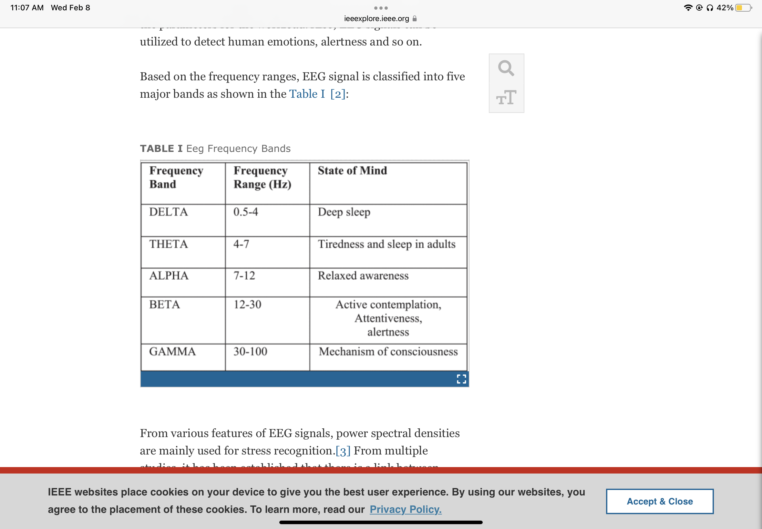
   4. [(PDF) Analysis of Single-Electrode EEG Rhythms Using MATLAB to Elicit Correlation with Cognitive Stress (researchgate.net)](https://www.researchgate.net/publication/282624417_Analysis_of_Single-Electrode_EEG_Rhythms_Using_MATLAB_to_Elicit_Correlation_with_Cognitive_Stress)
      1. Uses EEG headset with one electrode (????)
      2. 30 seconds of instructions, 60 seconds of Stroop test, questionnaire of stress on scale from 1 to 10
   5. [https://ieeexplore.ieee.org/document/958746](https://ieeexplore.ieee.org/document/9587468) EEG detection of stress during gameplay
   6. <https://ieeexplore.ieee.org/document/7319767>
   7. <https://www.alliedacademies.org/articles/real-time-stress-detection-system-based-on-eeg-signals.html>
      1. The placement of the electrodes used to measure stress in this experiment was:
      2. 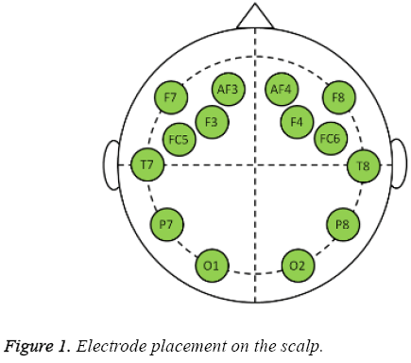
3. Data Collection
   1. Self-reporting survey of stress levels before baseline EEG recording (without stress stimulus)
   2. Electrodes will be placed mostly around the frontal lobe as there is increased brain activity in that area when a subject is under stress.
   3. Baseline and stress recordings
   4. Induce stress response
      1. Scaring someone
      2. Stressful video
      3. Stressful games

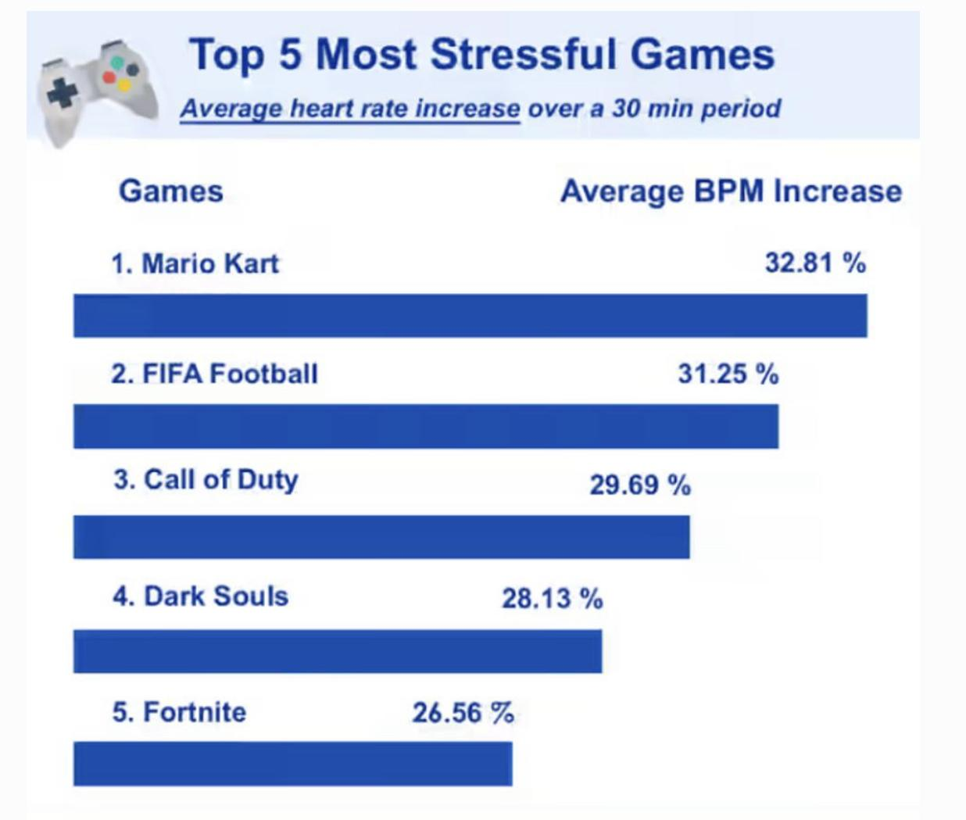

* + 1. Doing an assignment/ studying for a midterm
       1. Rogaway’s ECS 20 homework
       2. Bhaskar

1. Next Steps
   1. Conduct experiment to find a reliable indicator for stress (high beta waves)
   2. Code BCI to connect stress detector to computer response
2. Past BCI Projects
   1. <https://oaji.net/articles/2017/1992-1522322287.pdf>
      1. Not a BCI project but is entirely about finding the brains detectable stress response
         1. Provides lots of info on other studies’ findings
      2. Proposed Mechanism:
         1. Preprocessing: Discrete Cosine Transform, Discrete Wavelet Transform
         2. Possible Classifiers: Artificial Neural Network, Linear Discriminant Analysis, K-nearest neighbor, Naive Bayes, SVM
            1. ANN prone to large fluctuations in validation error if data set is small

Prohibitively memory intensive for training with large number of variables (> 45,000)

Must perform feature extraction on this data first to reduce number of variables

* + - * 1. Can use LDA to reduce dimensionality of data before performing further classification
        2. K-nearest neighbor has high accuracy for nonbinary stress classification
        3. SVM has high accuracy for binary stress classification